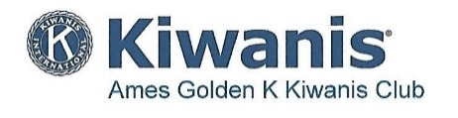

Membership Minutes

“dedicated to improving the world one child and one community at a time”
______________________________________________________________________________

April 1, 2021
Attendance: 42 members, 7 guests

Announcement, Business Items: Jerry Solbeck, Retention Winner, “Stash the Trash” coming up

Speaker: “Jack Trice Story,” Steve Jones, ISU Communications Manager

April 8, 2021

Attendance: 40 members, 10 guests (Nevada interclub, Iowa City interclub)

Announcements/Business: Jerry Solbeck, Retention Winner,
Stash-the-Trash: 20 volunteers, 24 hours, 18 bags of trash

Speaker: “ISU Cyclone Stories,” John Walters, I?SU ‘Voice of Cyclones’, ISU Athletic Dept.

_____________________________________________________________________________________

April 15, 2021

Attendance: 42 members, 6 guests (Iowa City interclub)

Announcements:

Speaker: “Ames History Museum,” Alex Fejfar, Exhibits Manager

April 22, 2021

Attendance: 33 members, 3 guests

Announcements/Business:

Speaker: “Early Epidemics at Iowa State, 1877-1918,” Doug Biggs, University of Nebraska

April 29, 2021

Attendance: 44 members, 4 guests

Announcements/Business:

Speaker: Neal Smith National Wildlife Refuge,” Nancy Corona, Visitor Services Manager

