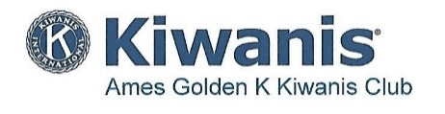
Membership Minutes

“dedicated to improving the world one child and one community at a time”
______________________________________________________________________________

November 5, 2020
Attendance: 45 members

Announcement, Business Items:

Speaker: “Iowa State Creamery,’ Stephanie Clark, Professor, ISU

November 12, 2020

Attendance: 43 members

Announcements/Business:

Speaker: “Street Railways in Ames, 1896-2019,” Bob Bourne, History, Ames
_____________________________________________________________________________________

November 19, 2020

Attendance: 41 members

Announcements/Business:

Speaker: “So You Wanna Be Average,” Leo Timms, ISU Dairy Science, Professor

